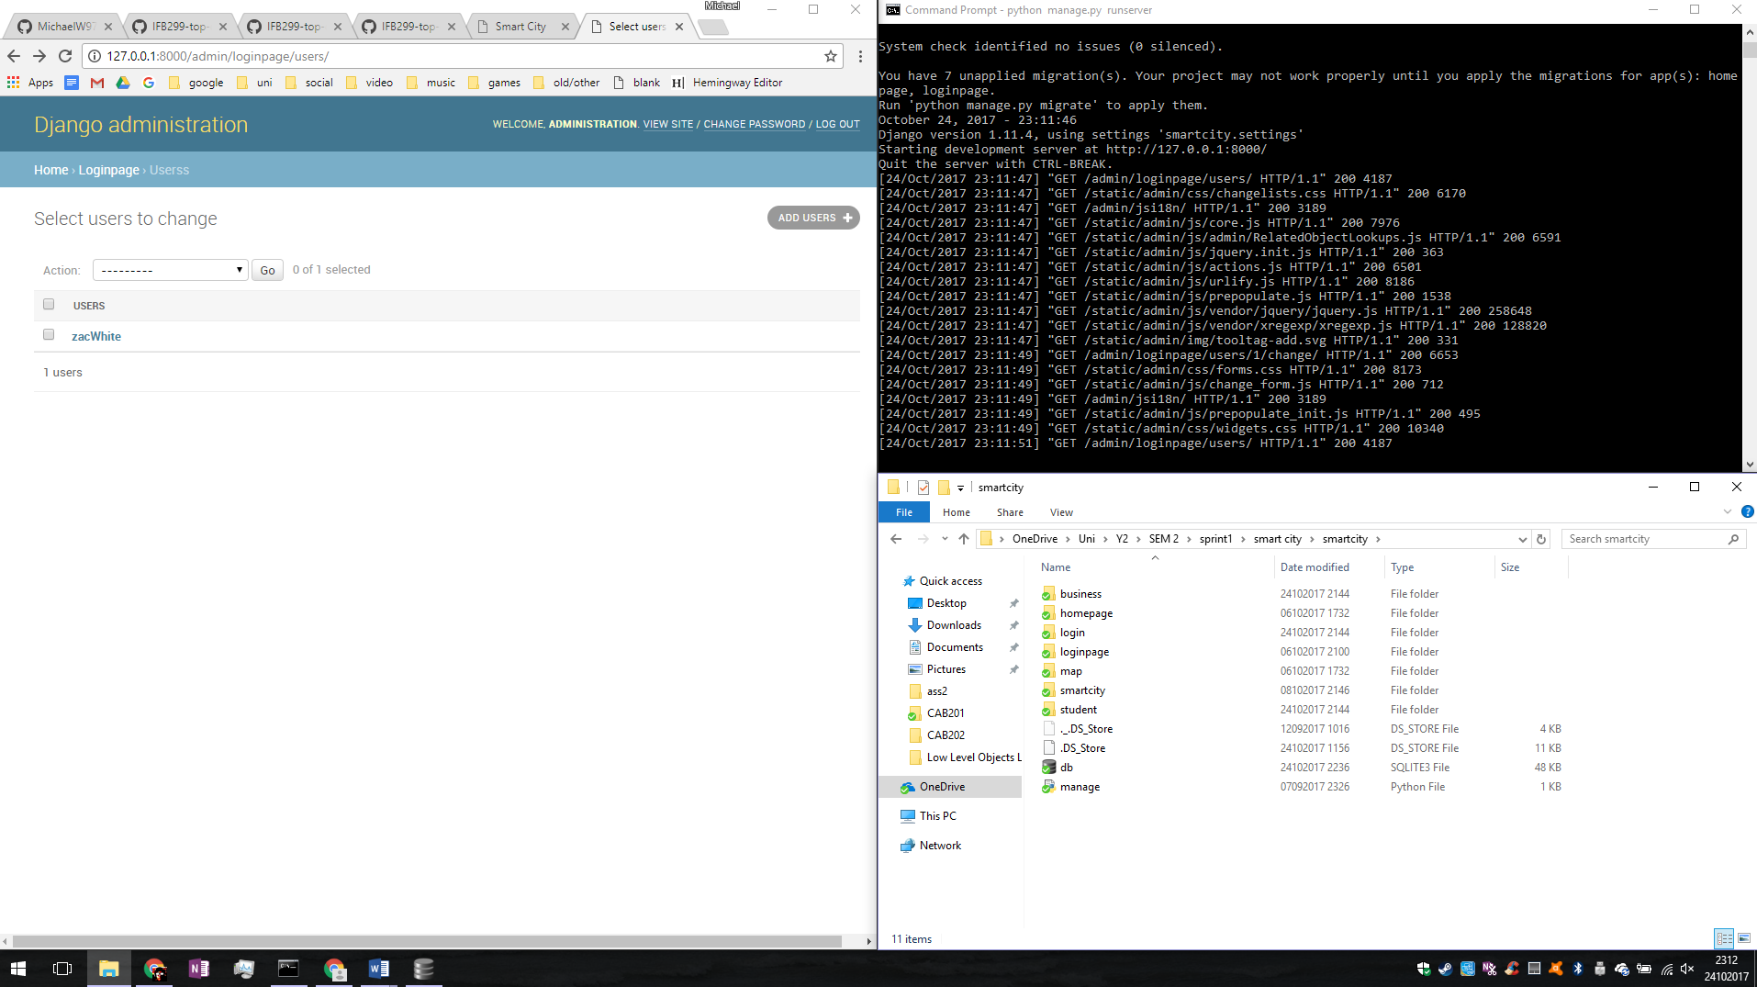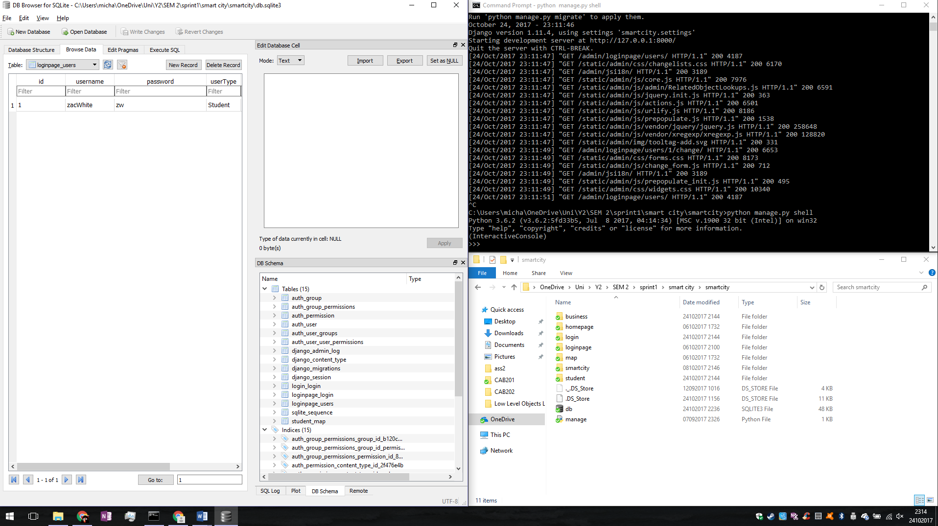

State of the users and data base from the admin perspective and sqlite browser before testing.

Next entering the shell with command python manage.py shell

Opening the database connections with from loginpage.models import Users

Looking at the existing database entries with Users.objects.all() shows us that zac is a previously entered data entry

Next entering new data require creating a new object and assigning the values. test = Users(username = "MichaelW", password = "secrete", userType = "Student", firstName = "Michael", lastName = "Wilkinson", email = "Michael@wilkinson.com")

To write it to the data base all that is left is to save test.save()

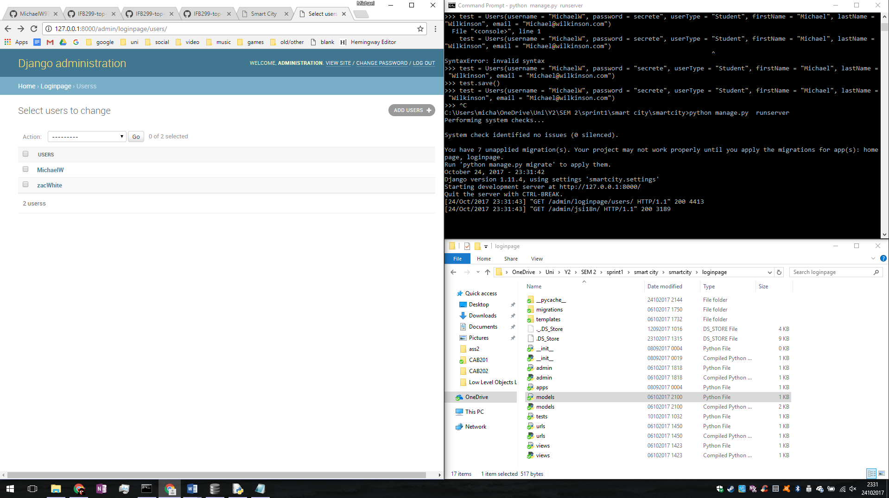 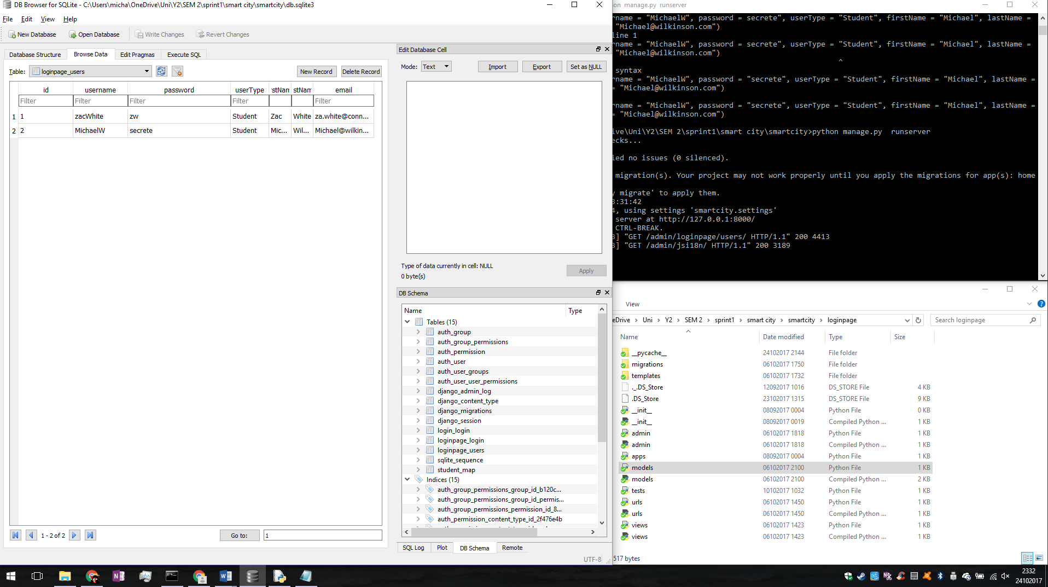

Again looking at the admin page and sqlite browser the data entered is saved correctly. This proves that the data base is implemented into the function of the website correnctly and is possible to edit data in this manner. This is inconclusive of the functionality between the webpages themselves and the data base however.

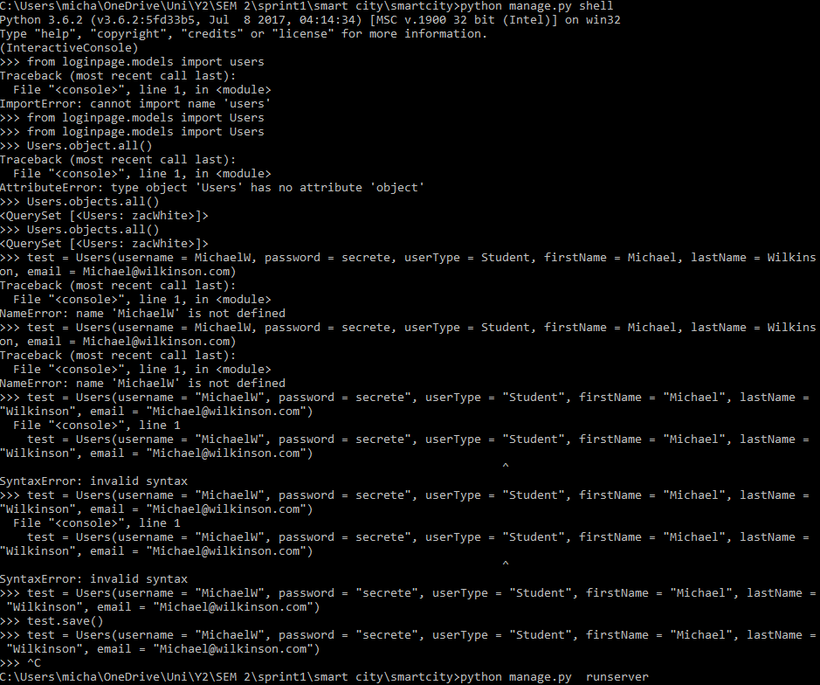The shell terminal window with input and outputs of the commands entered. Shell input errors blanked out for convinience.